
WASHINGTON
LEGISLATIVE OFFICE
AMERICAN CIVIL
LIBERTIES UNION
WASHINGTON
LEGISLATIVE OFFICE
915 15th STREET, NW, 6TH FL
WASHINGTON, DC 20005-2313
T/202.544.1681
F/202.546.0738
WWW.ACLU.ORG

Caroline Fredrickson
DIRECTOR

NATIONAL OFFICE
125 BROAD STREET, 18TH FL.
NEW YORK, NY 10004-2400
T/212.549.2500

OFFICERS AND DIRECTORS
NADINE STROSSEN
PRESIDENT

ANTHONY D. ROMERO
EXECUTIVE DIRECTOR

KENNETH B. CLARK
CHAIR, NATIONAL
ADVISORY COUNCIL

RICHARD ZACKS
TREASURER

January 17, 2007

SUPPORT BENNETT AMENDMENT S.A. 20 TO S.1 “THE LEGISLATIVE TRANSPARENCY AND ACCOUNTABILITY ACT OF 2007”

Dear Senator:

On behalf of the ACLU, a non-partisan organization with hundreds of thousands of activists and members, and 53 affiliates nation-wide, we urge you to support Bennett Amendment S.A. 20 to S. 1, the “Legislative Transparency and Accountability Act of 2007” when it comes to the floor for a vote. This amendment would strike Section 220 of the underlying bill.

Section 220, entitled “Disclosure of Paid Efforts to Stimulate Grassroots Lobbying” imposes onerous reporting requirements that will chill constitutionally protected activity. Advocacy organizations large and small would now find their communications to the general public about policy matters redefined as lobbying and therefore subject to registration and quarterly reporting. Failure to register and report could have severe civil and potentially criminal sanctions. Section 220 would apply to even small, state grassroots organizations with no lobbying presence in Washington. When faced with burdensome registration and reporting requirements, some of these organizations may well decide that silence is the best option.

The right to petition the government is “one of the most precious of the liberties safeguarded by the Bill of Rights.” When viewed through this prism, the thrust of the grassroots lobbying regulation is at best misguided, and at worst would seriously undermine the basic freedom that is the cornerstone of our system of government.

It is well settled that lobbying, which embodies the separate and distinct political freedoms of petitioning, speech, and assembly, enjoys the highest constitutional protection. Petitioning the government is “core political speech,” for which First Amendment protection is “at its zenith.”

Constitutional protection of lobbying is not in the least diminished by the fact that it may be performed for others for a fee. Further, “the First Amendment protects [the] right not only to advocate [one’s] cause but also to select what [one] believe[s] to be the most effective means of doing so.” In Meyer, the Court emphasized that legislative restrictions on political advocacy or advocacy of the passage or defeat of legislation are “wholly at odds with the guarantees of the First Amendment.”

Where the government seeks to regulate such First Amendment protected activity, the regulations must survive exacting scrutiny. To satisfy strict scrutiny, the government must establish: (a) a compelling governmental interest sufficient to override the burden on individual rights; (b) a substantial correlation between the regulation and the furtherance of that interest; and (c) that the least drastic means to achieve its goal have been employed.

A compelling governmental interest cannot be established on the basis of conjecture. There must be a factual record to sustain the government’s assertion that burdens on fundamental rights are warranted. Here, there is little if any record to support the contention that grassroots lobbying needs to be regulated. Without this record, the government will be unable to sustain its assertion that grassroots lobbying should be regulated.

The grassroots lobbying provision is troubling for other reasons as well. First, the provision seems to assume Americans can be easily manipulated by advocacy organizations to take actions that do not reflect their own interests. To the contrary, Americans are highly independent and capable of making their own judgment. Whether or not they were informed of an issue through a grassroots campaign is irrelevant--their action in contacting their representative is based on their own belief in the importance of matters before Congress.

Second, it appears groups such as the ACLU may end up having to report their activities because of the grassroots lobbying provisions. A “grassroots lobbying firm” means a person or entity that is retained by one or more clients to engage in paid efforts to stimulate grassroots lobbying on behalf of

such clients and receives income of, or spends or agrees to spend, an aggregate of $25,000 or more for such efforts in any quarterly period. “Client” under existing law includes the organization that employs an in-house staff person or person who lobbies. If, for example, the ACLU hires an individual to stimulate grassroots lobbying on behalf of the ACLU and pays that individual for her efforts in amounts exceeding $25,000, it appears that individual could be considered a grassroots lobbying firm, and have to register and report as such. The fact the ACLU employs that individual appears to be irrelevant to this provision. Unless this is the type of activity that the provision is intended to reach, there is no substantial correlation between the regulation and the furtherance of the government’s alleged interest in regulating that activity.

Groups such as the ACLU could also be affected because of the definitions of “paid efforts to stimulate grassroots lobbying” employed in Section 220. For example, the ACLU maintains a list of activists who have signed up to be notified about pending issues in Congress. Not all of those activists are “dues paying” members who would be exempt from consideration for “paid efforts to stimulate grassroots lobbying.” Additionally, since there are 500 or more such individuals, sending out an action alert to ACLU activists could be deemed “paid” communication and subject to registration and quarterly reporting.

Because the grassroots lobbying provision is unsupported by any record of corruption, and because the provision is not narrowly tailored to achieve the government’s asserted interest, the provision is constitutionally suspect. Requiring groups or individuals to report First Amendment activity to the government is antithetical to the values enshrined in our Constitution. If our government is truly one “of the people, for the people, and by the people,” then the people must be able to disseminate information, contact their representatives, and encourage others to do so as well.

Sincerely,

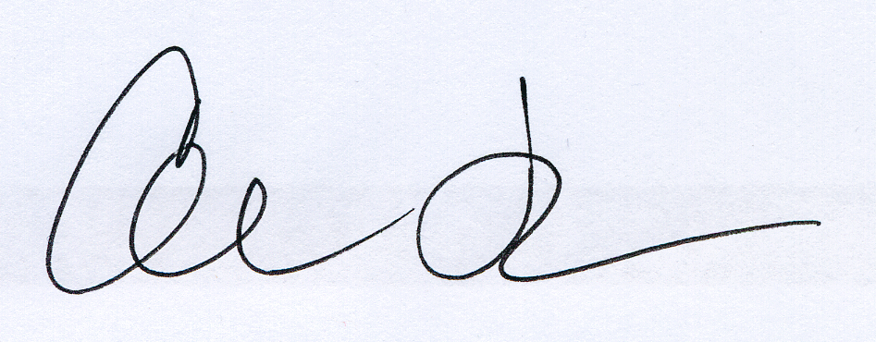
Caroline Fredrickson
Director, Washington Legislative Office

Marvin Johnson
Legislative Counsel

United Mineworkers Union v. Illinois State Bar Association, 389 U.S. 217, 222 (1967).
Buckley, supra. at 45 (1976).
Meyer v. Grant, 486 U.S. 414, 425 (1988).
Riley, supra. at 801 (1988).
Meyer v. Grant, supra. at 424.
Id. at 428.
Buckley, supra. at 64.
Id. at 68.

